Vedant Sanap D15A 48

Experiment 6

**Aim:**

To Build, change, and destroy AWS / GCP /Microsoft Azure/ DigitalOcean infrastructure Using Terraform.(S3 bucket or Docker)

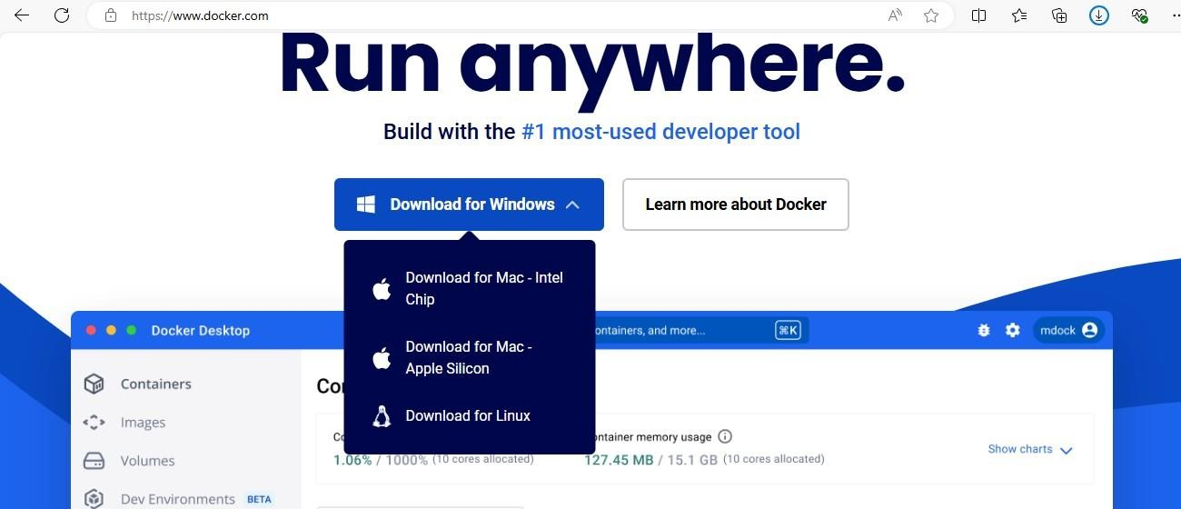Step 1: Download Docker form [www.docker.com](http://www.docker.com/)

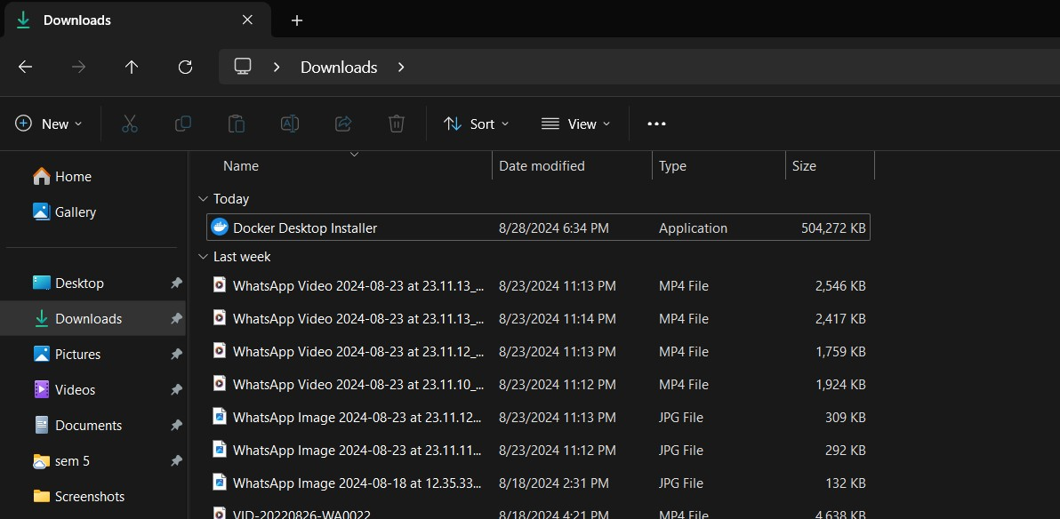Step 2: The Docker is successfully downloaded. Now, run the docker installer and complete the installation.

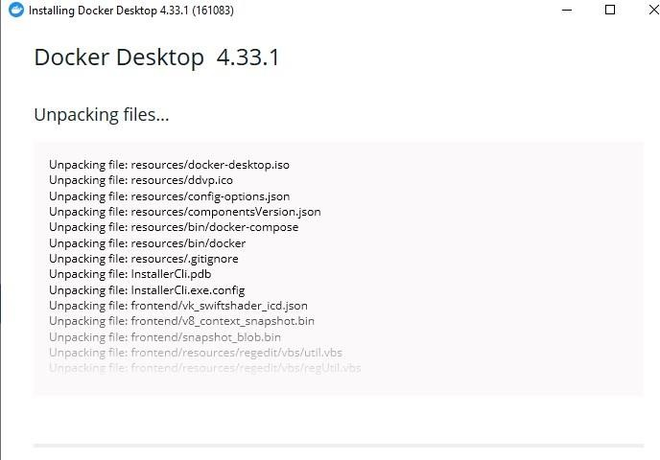

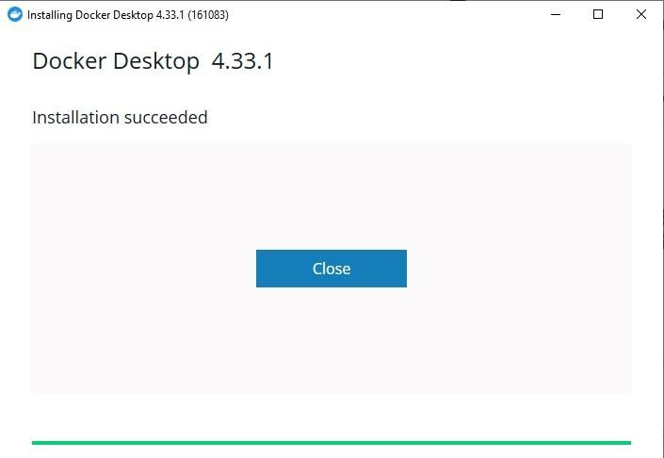

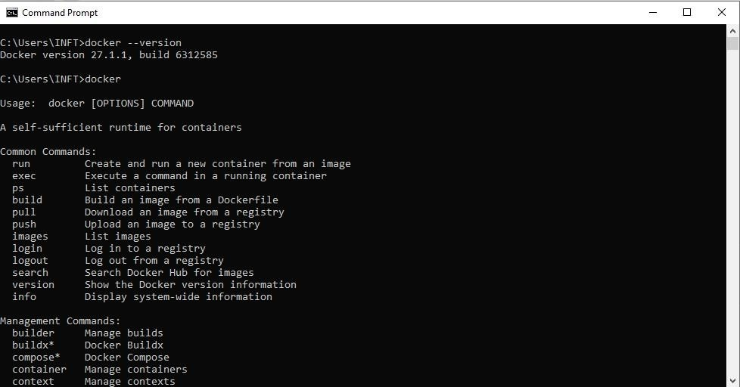Step 3: Open Command Prompt and run as administrator. Enter the command docker –version, to check whether the docker is successfully installed.

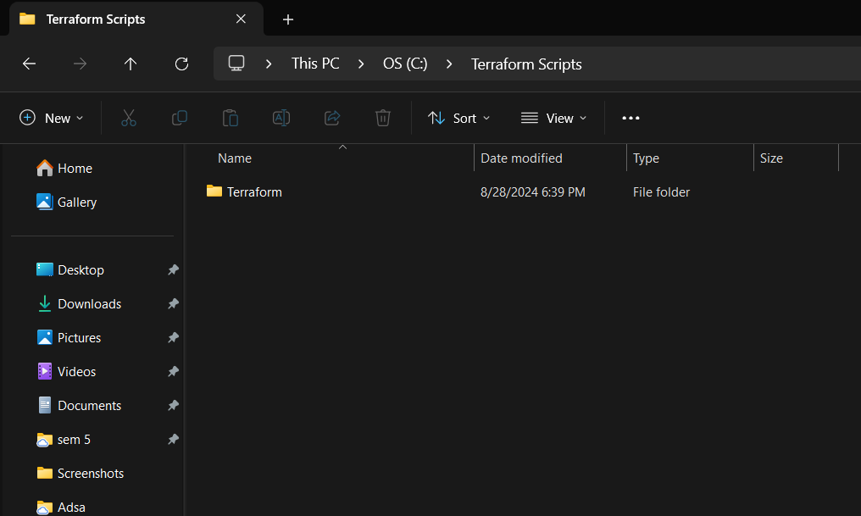Step 4: Create a folder Terraform_scripts and inside it create a folder named Docker.

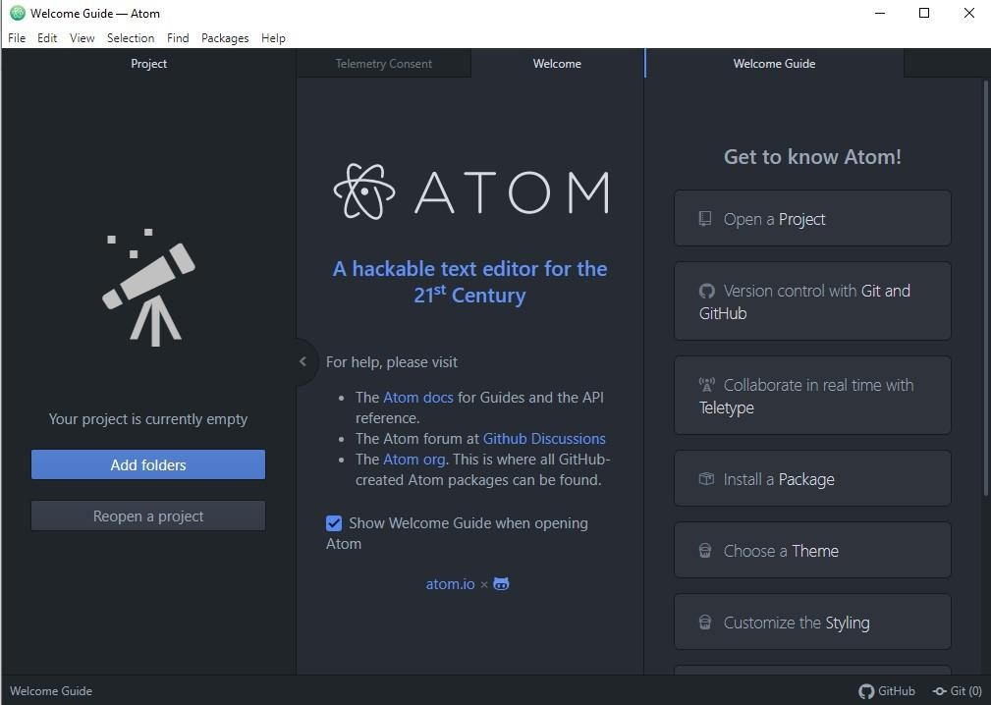Step 5: Download Atom Editor.

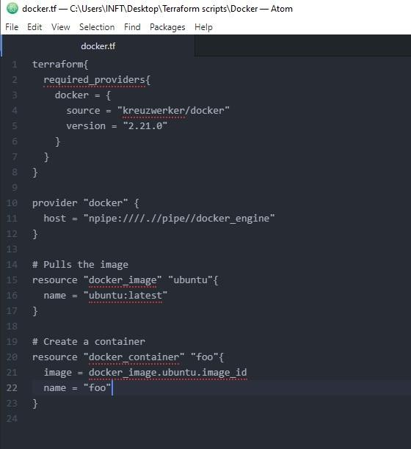Step 6: Run the following script in the Atom Editor

Step 7: Open Windows Explorer and run the following command terraform init, terraform plan, terraform apply, terraform destroy and docker images.

